

ATHLETIC & RECREATIONAL SURFACES: 32 18 00 (02791)

SALES & MARKETING DEPT: MANUFACTURING PLANT:

Unity Surfacing Systems Unity Creations, Ltd.
56 Bloomingdale Rd. 3997 RT 9W (PO Box 9)
Hicksville, NY. 11801 Saugerties, NY. 12477
T: (516) 724-1357 T: (845) 246-2700
F: (845) 246-1700 F: (845) 246-1700
E-mail: productinfo@surfacingsystems.com E-Mail techinfo@surfacingsystems.com
Internet: www.surfacingsystems.com Internet: www.surfacingsystems.com

10-Part Specification – based on CSI and CSC Formats
Section 32 18 16.33 (02791). Playground Protective Surfacing

PART 1: GENERAL

  - Section Includes:

Resilient, self-interlocking (with “Button-Lock™ Technology”) unitary, rubberized safety surfacing, flooring and paver products in the tile/mat/block/paver form with bolt-down capabilities.

  - Related Sections:

Division 32
Sub: 32 18 00 Athletic and Recreational Surfaces .
Specifically; 32 18 16 Synthetic Resilient Surfaces.
Specifically; 32 18 16.33 Playground Protective Surfacing.
Specifically; 32 18 23 Athletic Surfaces.
Division 9
Sub: 09 65 00 Resilient Flooring
Specifically: 09 65 19 Resilient Tile Flooring.
Specifically: 09 65 19.33 Rubber Tile Flooring.
Specifically: 09 65 66 Resilient Athletic Flooring.
Division 11
Sub: 11 68 00 Playfield Equipment and Structures .
Specifically; 11 68 13 Playground Equipment.
Specifically: 11 68 16 Play Structures.
  - References

- Applicable Standards:
American Standard for Testing Materials (ASTM)
Consumer Product Safety Commission (CPSC)
American National Standards Institute (ANSI)
Factory Mutual (FM)

- ASTM F1292-04 and F355-95 Drop Test
Standard Test Method for Impact Attenuation of Surface Systems Under and Around Playground Equipment.

- ASTM C67 Weathering/Aging
Standard Test Method for Weathering and Aging of Surface Systems and Materials.
Standard Test Method for Rubber – Deterioration in an Air Over.

- ASTM E108: Class A Fire Test/Flammability
Standard Test Method for Fire Tests of Surface Systems and Materials.

- ASTM E108 Class A Fire Test/Flammability - Modified For Roof Coverings:
Modified Test Methods for Fire Tests of Roof Covering Materials.

- ASTM E648 Self Extinguishing Fire Test/Flammability
Standard Test Method for Critical Radiant Flux of Floor Covering Systems Using a
Radiant Heat Energy Source (NFPA Designation No. 253).

- ASTM D2859 Burn Pill
Standard Test Method for the Surface Flammability of Products (Burn Pill Test).

- ASTM E303-93 (2013) Skid Resistance
Standard Test Method for Measuring Surface Frictional Properties Using the British Pendulum Tester.

- ASTM F1951-99 ADA Accessibility
Standard Specification for Determination of Accessibility of Surface Systems Under and Around Playground Equipment.

J.) ASTM C518-98 Insulation/R-Values
Standard Test Method for Steady-State Thermal Transmission Properties by Means of the Heat Flow Meter Apparatus. Measuring = Insulation/R-Values.

K.) ASTM E903, E891, E1980 Solar Reflectance
Hemispherical Spectral Reflectance and Total Emittance Test. Presents results of spectral reflectance and total emittance of products tested.

L.) CPSC-CH-E1002-08 Lead Content
LEAD Test - For compliance with US Public Law 110-314 (HR 4040 “Consumer Product Safety Improvement Act of 2008”), lead in accessible substrate materials.

M.) Water Penetration Test:
For compliance with Sustainable Storm Water Run-off in a testing environment to determine how much water flows through the product based on real world scenarios.

N.) Leadership in Energy and Environmental Design (LEED):
1.) Criteria development by the United States Green Build Council (USGBC):
a.) Materials and Resources:
Up to 6 points / credits toward LEED certification.
b.) Indoor Environmental Quality:
Up to 1 point / credit toward LEED certification.

O.) ANSI/FM 4474 Wind Up-Lift
Simulated Wind Up-lift Pull-Force Test Procedure (adhered), to allow design pressure that is
estimated to be 277.5 psf. (2:1 Factor of Safety) for systems installed in this manner.

P.) ASTM D 3161-09 Non-Adhered, Over-Top and at Kick-Plate) Modified for Rubber Pavers
Standard Test Method for Wind Resistance (Fan-Induced) via air velocity of 150 MPH.

Q.) UL 2218, Class 4 Impact Resistances, 2010.
Standard Test Method for Impact Resistance of Prepared Roof Covering Materials.

R.) ASTM D 412(13) Tensile Strength, Elongation at Break and Modulus
Standard Test Methods for Vulcanized Rubber and Thermoplastic Elastomers – Tension.

S.) ASTM D 624 Tear Resistance
Standard Test Method for Tear Strength of Conventional.

T.) ASTM D 3389 (10) Taber Abrasion Index
Standard Test Method for Walking Surface Based on Abrasion Cycles.

U.) ASTM D 2240 Durometer Hardness
Standard Test Method for Measuring the “Hardness” of Rubber Elastomers and Plastic.

V.) ASTM D 1667 Compression Deflection
Standard Test Method for Flexible Cellular Materials.

W.) ASTM E-831 Coefficient of Thermal Expansion
Standard Test Method for Thermal Expansion of Materials by Thermomechanical Analysis

X.) ASTM D 3574 Compression Resistance
Standard Test Method for Flexible Cellular Materials.

Y.) ASTM D 3676 (13) and D 395 Mass and Density Per Unit Area, including Compression Set
Standard Specification for Rubber by way of Mass, Density and Recovery Per Area.

Z.) Tensile Strength at Interlocking Joint
For compliance with Pull Force in a testing environment to determine how much pressure it takes to unlock the interlocking joints based on real world scenarios.

1.4 Submittals:

A.) General:
1.) Submit listed submittals in accordance with Conditions of the Contract and Division pertaining to Submittal Procedures Section.

B.) Product Data:
1.) Submit manufacturer’s product data, specifications, detailed drawings and installation
Instructions, as well as manufacturer’s maintenance and cleaning instructions.

C.) Verification Samples:
1.) Submit manufacturer’s standard verification samples of 4”X4” minimum. Two of the submitted samples must show the male/female self-interlocking connection (with “Button-Lock™ Technology”) and Bolt-down capabilities.

D.) Manufacturers Project References:
1.) Submit reference list of at least 20 years of projects on all sizes, types and scopes.
2.) Include project name, location and contact person of three (3) projects that are similar in size, type and scope as specified herein.

E.) Installer’s Project References:
1.) Submit a copy of manufacturers issued installation warranty certification.
2.) Installers must have 5 years’ experience with projects of similar scope & complexity.

` F.) Closeout Submittals: Submit the following:
1.) Warranty documents as specified herein.
2.) Repair & Maintenance documents as issued by the manufacturer.
3.) Photographs of completed installation, with close-up shots of cut tiles.
4.) Submit listed “Closeouts” in accordance with Conditions of the Contract and Division pertaining to Closeout Procedures Section.

- Approvals:
1.) Contact manufacturer for information on approvals by major owners, agencies, architects, engineers, municipalities and other industry entities.

- Environmental Considerations:
1.) These resilient, rubberized safety surfacing flooring and paver products in the tile/mat/ block/paver form makes extensive use of clean recycled tire rubber and other recycled rubber products as a major component of its operation that are sourced/ recycled in the United States of America.

- Testing Data Results:
1.) Submit certified test reports from qualified independent testing agency indicating
results of the following testing:

a.) Applicable Standards:
b.) Impact Attenuation (ASTM F1292-04 & F355.95)
c.) Weathering/Aging (ASTM C67, D573 & F1292-04)
d.) Flammability/Fire Test (ASTM E108)
e.) Flammability (ASTM E108 Modified for roof covers)
f.) Flammability (ASTM E648)
g.) Flammability/Burn Pill Test (ASTM2859)
h.) Skid Resistance (ASTM E303-93 / 2013)
i.) ADA Accessibility (ASTM F1951-99)
j.) R-Value, Thermal Conductivity (ASTM C518-98)
k.) Reflectance/SRI and Emittance (ASTM E903, E891, E1980)
l.) Lead In Materials/Children’s Products (CPSC-CH-E1002-08)
m.) Water Penetration Test (Sustainable Storm Water MGT/Run-off)
n.) Leadership in Energy and Environmental Design (LEED)
o.) Pull Force Test (ANSI/FM 4474 Approval, Appendix B)
p.) Wind Resistance (ASTM D3161-09)
q.) Class 4 Impact Resistance (UL 2218, 2010)
r.) Tensile Strength, Elongation at Break and Modulus (ASTM D 412)
s.) Tear Resistance (ASTM 624)
t.) Taber Abrasion Index (ASTM D3389)
u.) Durometer Hardness (ASTM 2240)
v.) Compression Deflection (ASTM 1677)
w.) Coefficient of Thermal Expansion (ASTM 831)
x.) Compression Resistance (ASTM 3574)
y.) Mass & Density (ASTM 3676) with Compression Set (ASTM D395)
z.) Tensile Strength at Interlocking Joint (Pull Force)

  - Quality Assurance/Control:

- Manufacturers Qualifications: Manufacturer shall meet a minimum of one (1) of the following two (2) requirements:
- Consistently engaged in manufacturing of self-interlocking rubber tiles/mats/blocks/ pavers of similar type that is specified, with a minimum of fifteen (15) years of experience under the same business name and EIN (Employer Identification Number)
- Furnished/Supplied a minimum of ten-million (10,000,000) square feet of self-interlocking rubber tiles/mats/blocks/pavers of similar type that is specified.

B.) Installers Qualifications:
1.) Installers must have 5 years’ experience with projects of similar scope & complexity.
2.) Certificate of qualifications from the product installer verified by manufacturer.
1.6 Delivery, Storage and Handling

A.) Delivery:
1.) All materials shall be delivered in good condition in its original unopened packages, bound and shrink wrapped with all labels intact clearly identifying manufacturer, product series/name, color and type.
B.) Storage:
1.) All materials and accessory items shall be protected from weather; and shall be stored at temperatures of 50 degrees Fahrenheit (10 degrees C) and rising for 24-hours min.
2.) Protect all materials and accessory items from direct sunlight before and during installations.
C.) Handing:
1.) Protect all materials and accessory items during handling and installation to prevent unnecessary damage.

1.7 Environmental Requirements

A.) Tile and Air Temperatures:
1.) Ensure both the tile and air temperature is a minimum of 50 degrees Fahrenheit (10 degrees C) and rising for 24-hours min.
2.) Consult with manufacturer’s installation guide/manual for installations in conditions less than 50 degrees Fahrenheit (10 degrees C) and/or greater that 85 degrees Fahrenheit (29 degrees C).

1.8 Warranty Information
A.)Manufacturer’s Warranty:
1.) Submit, for Owner’s acceptance, manufacturer’s standard warranty document executed by authorized company official. Manufacturer’s warranty is in addition to, and
not a limitation of, other rights Owner may have under contract documents.

B.) Material Warranty Period:
1.) Standard Five (5) Years from date of product shipment; or a Ten (10) Year Pro-rated
Warranty from date of product shipment shall be selected prior to ordering. A default Five (5) Year Pro-rated Warranty shall be issued if no other warranty is selected prior to ordering.
C.) Installation/Workmanship Warranty Period:
1.) Standard Three (3) Years from date of product installation; or a Five (5) Year Pro-rated Warranty from date of product shipment shall be selected from the certified installer prior to ordering. A default One (1) Year Warranty shall be provided by the contractor directly if no other warranty is selected prior to ordering.

PART 2: PRODUCTS
2.1 Manufacturer

A.) Unity Surfacing Systems, A Product of Unity Creations, Ltd. 3997 Route 9W (PO Box 9) Saugerties, New York 12477. Toll Free: (1-877) 41-UNITY, Phone (845) 246-2700, Fax: (845) 246-1700, E-mail: productinfo@surfacingsystems.com, Internet: www.surfacingsystems.com

2.2 Playground Protective Surfacing
A.) Description:
1.) Self-Interlocking Tile/Mat/Block/Paver size: 22” X 44” = 6.72 sq. ft. per unit (pre-cured). Cured products will measure 21.75” X 43.5” = 6.57 sq. ft. per unit.
2.) Transitional Ramp Edge size: 22” X 44” (slope can be found in the 22”). Cured products will measure 21.75” X 43.5” = 6.57 sq. ft. per unit.

B.) Basic Use:
1.) Designed for playgrounds, rooftops, walkways, recreational areas, weight rooms, patios, pools of all types. It is installed over poured asphalt (blacktop), concrete (cement) or compacted crushed stone substrate. It is also suited for rooftop applications. The product line features an extensive range of standard tile/mat/block/paver colors and thicknesses with many design capabilities and accessory pieces.

- Composition and Materials:
1.) The Unity, self-interlocking (w/Button-Lock™ Technology), resilient, rubberized
safety surfacing flooring and paver products in the tile/mat/block/paver form offers shock resistance. Comes in seven (7) standard thicknesses and can be produced from ½” to 4” (4.0”) in thickness. Consists of three product families: Post-Consumer Black Recycled SBR (Styrene Butadiene Rubber) - recycled in-house, Pigmented Dye and/ or TPV (Thermoplastic Vulcanized Rubber)/ EPDM (Ethylene Propylene Diene Monomer). a.)
a.) Pigmented top tiles are produced with 100% post-consumer black
recycled SBR (Styrene Butadiene Rubber) coating said recycled rubber
granules to achieve a desired color.
b.) The TPV/EPDM top tiles/mats/blocks/pavers are recycled post-industrial TPV/EPDM rubber, available in a variety of colors and color combinations.
c.) All of which, are mixed with a polyurethane and molded with heat and pressure into finished products.

2.) Unity offer a solid layer construction with bottom designs consisting of solid cones (feet and/or legs) for maximum surface contact offering a built-in self-interlocking system with Button-Lock™ technology, and bolts down. This allows maximum contact between the tile/mat/ block/ paver bottom and base as well as between adjacent products.
3.) The type of playground equipment, athletic and recreational and/or roof specifications determines the required tile/mat/block/paver thickness. Depending on ASTM F1292-04 requirements for critical fall height from 0’-12’ (feet), select tile thickness from optional thicknesses: ½” & ¾” thick “Tough-Land” Series, 1 ¾” (1.75”) thick “Pave-Land” series for a five (5’) foot fall rating, 2 ½” (2.5”) thick “Play-Land” series for a seven (7’) foot fall rating, 3” thick Soft-Land” series for an eight (8’) foot fall rating, 3 ½” (3.5”) thick “Soft-Land” series for a ten (10’) foot fall rating, and the 4” thick “Soft-Land” series currently testing to achieve a twelve (12’) foot fall rating respectively.
4.) Accessories include:
a.) Unity’s Chemrex 948 Urethane Adhesive (Large Tubes) – For gluing interlock-to-interlock adhesion as well as product-to-solid sub-base installations.
b.) Unity’s Transitional Ramp, Standard Beveled Edge – For above grade installations. Slope is standard at 22”, but can also be set at 44” for ADA.
c.) Unity’s Geotextile Fabric, Landscaping Mesh – For rooftop installations and loose-filled ground level installation only. MUST CUT AWAY FROM DRAINS.
d.) Unity’s Anchor Bolts (for bolt-down installations) – For solid sub-base ground level installations only. DO NOT USE ANCHOR-BOLTS ON ROOFTOPS.

D.) Thickness and Weights:
½” thick………….………………..~ 10 lbs. each or ~ 2.5 lbs. per sq. ft. (2ft. X2ft. only).
¾” thick………….……………….~ 15 lbs. each or ~ 3.75 lbs. per sq. ft. (2ft. X2ft. only).
1 ¾” (1.75”) thick. ..........................~ 37 lbs. each or ~ 5.5 lbs. per sq. ft. (22”X44” only).
2 ½” (2.50”) thick…………………~ 40 lbs. each or ~ 6.0 lbs. per sq. ft. (22”X44” only).
3” thick……………………………~ 44 lbs. each or ~ 6.5 lbs. per sq. ft. (22”X44” only).
3 ½” (3.5”) thick…………………..~ 47 lbs. each or ~ 7.0 lbs. per sq. ft. (22”X44” only).
4” thick……………………………~ 50 lbs. each or ~ 7.5 lbs. per sq. ft. (22”X44” only).

Note: Adjustments can be made with reference to weight related issued for each unit.

- Wear Layer for 1 ¾”, 2 ½”, 3”, 3 ½” and 4” thick products is standard at one (1”) inch thick.

- Base Layer: Integral solid cone pedestal design/pattern underside forming channels for water drainage between protective surfacing and substrate to drainage outlet.
G.) Color:
1.) Pigmented Color (minimum 3/8” thick):
a.) Black, Splash (Black with 10% to 50% TPV/EPDM granules sprinkled on top), Slate Gray, Red (Terra Cotta), Grass Green, Sky Blue, Sandy Tan, Mystic White, Choc Brown.

- TPV/EPDM Colors (minimum ¼” thick):
a.)Red (Terra Cotta), Brt. Red, Green, Brt. Green, Dark Green, Blue, Lt. Blue,
Azure Blue (Teal), Purple, Lt. Purple, Turquoise, Beige, Eggshell (Cream),
Brown, Dark Brown, Mustard Yellow, Brt Yellow, Orange, Dark. Gray, Mid-Gray, Lt. Gray, Virgin Black. Can be blended for a solid TPV top using up to three (3) color(s) at any percentage(s) desired for a custom look.

H.) Limitations:
1.) The following chemicals may cause damage to the rubberized safety surfacing,
flooring and paver products, and should be avoided:
a.) disinfectants, concentrated chlorine bleach, gasoline, diesel fuel, hydraulic and
lubricating oils, acids and organic solvents.

2.) In water play areas, pool surrounds and similar applications; dissolved minerals and
other chemicals (hydrochlorides) may cause surface discoloration over time. This
condition, should it occur, is not considered to be a product failure.
3.) Due to the elastic characteristics of recycled rubber products, some variation in dimensions may be expected. Plan for product dimensions of 21¾” X 43½” on items 1 ¾” thick and higher.
I.) Testing Data Results:
1.) Shock Attenuation (ASTM F1292-04 & F355.95):
a. G-max – Less than 200 = ……………………….….…………………PASSED.
b. Head Injury Criteria – Less than 1000 = …………………...................PASSED.
c. 1 ¾” = 5 foot fall rating, 2 ½” = 7 foot fall rating, 3” = 8 foot fall rating, 3 ½” =
10 foot fall rating and 4” = 11 foot fall rating.
2.) Weathering/Aging (ASTM C67, D573 & F1292-04): =……………...……..PASSED.
a. 1 ¾” = 5 foot fall rating, 2 ½” = 7 foot fall rating, 3” = 8 foot fall rating, 3 ½” =
- foot fall rating and 4” = 11 foot fall rating.
b. Rubber Deterioration in an Air Over (ASTM D573)….NO DETERIORATION.

3.) Flammability/Fire Test (ASTM E108)………………..MEETS “CLASS A” RATING.
a. At 1minute 45 seconds the flames traveled four feet along the tip of the sample.
At 2 minutes 29 seconds the flames receded to two feet. After 10 minutes of
flame exposure at a deck slope of one-quarter in per horizontal foot in 12 mph
wind velocity, the burner was shut off. The sample stopped burning 38 seconds
after the flame was shut off.

4.) Flammability (ASTM E108 Modified for roof covers):.MEETS “CLASS A” RATING
a. Ignition Time = 7:24, Maximum Spread of Flame = 40”, Time of Maximum
Spread = 8:25. Observations = The Burner Flame was shut off at 10 minutes
and the specimen self-extinguished at 13 minutes and 55 seconds, meeting
Class A.

5.) Flammability (ASTM E648)…………………………...MEETS “CLASS I” RATING.
a. Each Specimen was laid flat over a ¼” Etera board (a cement asbestos
substitute using PC: 96H. Critical Radiant Flux (watts/cm2) averaged = 0.58.

6.) Flammability/Burn Pill Test (ASTM2859)……...........W/NO OFF GASSING @ 3.7”.
a. Distance (inches) shall be greater than 1” for all eight test samples to comply.
7.) Skid Resistance (ASTM E303-93 / 2013)……………………………………PASSED.
- Dry = …………………………………………….………………………80.25.
- Wet = ……………………….………………………………………………67.
8.) ADA Accessibility (ASTM F1292-99): = ………………….………………..PASSED.
a. Firmness = ………………………………………………………………….0.26.
b. Stability = …………………………………………………………………..0.28.
9.) R-Value, Thermal Conductivity (ASTM C518-98): = …………...2.4 COMPLIANCE.
a. Hot (F) = 96.78, Cold (F) = 50.68, Average = 73.73, Thermal Conductivity
Btu-in/hr-ft2-F.

10.) Reflectance/SRI and Emittance (ASTM E903, E891, E1980)….VARIES (see below)
Specimen Code | % Solar Reflectance | SRI | Reflectance (p) Measured | Near-Normal Emittance € Calculated
EPDM Blended Top | 58.8 | 72 | 0.05 | 0.95
Mystic White | 20 | 22 | 0.04 | 0.96
Sandy Tan | 11.9 | 12 | 0.03 | 0.97
Sky Blue | 7.8 | 7 | 0.03 | 0.97
Wheat | 39.4 | 46 | 0.05 | 0.95
Choc. Brown | 5.1 | 3 | 0.04 | 0.96
Slate Grey | 6.7 | 5 | 0.06 | 0.94
Terra Cotta RED | 5.9 | 3 | 0.06 | 0.94
Grass Green | 6.7 | 5 | 0.06 | 0.94
TPV White | 68.6 | 86 | 0.04 | 0.96
TPV Blended Colors | 46.4 | 55 | 0.04 | 0.96

11.) Lead In Materials/Children’s Products (CPSC-CH-E1002-08):….NOT DETECTED.
a. CPSIA Section 101: Rubber Tile/Mat/Block/Paver: Lead Content (ppm) = ND.
MDL = 2 ppm, Permissible Limit = 300 ppm, Conclusion = Pass.

12.) Water Penetration Test (Sustainable Storm Water MGT/Run-off)………….VARIES.
a. BODY = Penetration is .13 Gallons Per Minute, Per Square Foot of surface area
b. SEAM = Penetration is .21 Gallons Per Minute, Per Square Foot of surface area

13.) Leadership in Energy and Environmental Design (LEED):
a. Criteria development by the United States Green Build Council (USGBC):
1.) Materials and Resources:
Up to 6 points / credits toward LEED certification.
Recycled Content………………………...MR. 4.1
Recycled Content………………………...MR. 4.2
Local/Regional Materials…………………MR 5.1
Local/Regional Materials…………………MR 5.2
Construction Waste Mgt………………….MR 2.1
Construction Waste Mgt………………….MR 2.2

2.) Indoor Environmental Quality:
Up to 1 point / credit toward LEED certification.
Low Emitting Materials…………………..EQ 4.1
14.) Pull Force Test On Solid Sub-Base (ANSI/FM 4474 Approval, App. B)….277.5 psf.
a. Allowable design pressure (2:1 Factor of Safety) for systems installed in
the manner described.

15.) Wind Resistance (ASTM D3161-09), Over-Top and At Edge Kick-Plate):.150 MPH.
a. Over Top = No movement observed after 2 hours continuous exposure.
b. Kick Plate = Lifting observed in center of specimen. Sample remained
intact and on roof membrane after 2 hours of continuous exposure.

16.) Class 4 Impact Resistance (UL 2218, 2010) ……………………………….PASSED.
a. Six different drop zones observed no damage. No evidence of tearing,
fracturing, cracking, splitting, rupturing, crazing, or other evidence of
opening of the rubber paver system.

17.) Tensile Strength, Elongation at Break and Modulus (ASTM D 412) ….[MPa] &.[%].
a. Tensile Strength……………………………………………….0.87 Mpa.
b. Tensile Strength at Break……………………………………..0.76 Mpa.
c. Elongation…………………………………………………….......71.5%.
d. Elongation at Break………………………………………………92.4%.
e. Modulus……………………………………………………….3.49 Mpa.

18.) Tear Resistance (ASTM 624)…………………………………………[N] &.[kNm].
a. Peak Tearing Load………………………………………………..156 N.
b. Peak Tearing Strength ………………………………………..11.3 kNm.

10.) Taber Abrasion Index (ASTM 624)………………………………………0719 WC.

20.) Durometer Hardness (ASTM 2240)…………………………………….Shore A = 54.

21.) Compression Deflection (ASTM 1677)……………………………..577 kPa @ 25%.

22.) Coefficient of Thermal Expansion (ASTM 831)………………0013 in/ft. per degree.

23.) Compression Resistance (ASTM 3574)………………………………[kN] &.[kPa].
a. Load at Preset point……………………………………………..2.78 kN.
b. Compression Resistance………………………………………1030 kPa.

24.) Mass & Density (ASTM 3676)………………………………………psf & pcf/kg/m3
a. Mass Per Area…………………………………………………...2.92 psf
b. Density Per Area…………………………………...78.8 pcf/1282 kg/m3
c. Recovery (D395)………………………………90-100% w/No Cracking

25.) Tensile Strength at Interlock Joint (Pull Force To Separate Interlock)…...Two Ways.
a. Vertical Pull Force Test……………………………..127 PSI or Greater.
b. Horizontal Pull Force Test……………………………38 PSI or Greater

PART 3: TECHNICAL INFO

3.1 Unity’s Tile Details (official/firm):

3.2 Transitional Ramp (Edging) Details (official/firm):

3.3 Transitional Ramp (Edging) Cutting Details for Inside and Outside Corners (official/firm):

PART 4: EXECUTIONS

4.1 Examinations/Inspections

A.) Prior to application of the Unity’s products, the architect, engineer, municipality, general contractor, safety surfacing manufacturer and installer shall evaluate the substrate’s structural performance. Notify all contactors, architects and engineers of all displacements or stress cracks. Work shall not proceed until unsatisfactory conditions are corrected and signed by the contractors, architects and engineers; And Unity’s installation manual/guide has been read.

4.2 Preparations

A.) Do not proceed with safety surfacing, flooring and/or paver installation until all applicable site work, including substrate preparation, fencing, playground equipment installation, roofing and other relevant work, has been fully completed and approved. Verify that substrate conditions are suitable for installation of the safety surfacing, flooring and pavers; and do not proceed with installation until unsuitable conditions are corrected, verified and approved.

B.) Recessed installations are strongly encouraged to avoid the use of transitional ramps (edging) as this allow for the entire area to be ADA accessible and not just one ramp/zone/area. It is both helpful and advised to plan accordingly when preparing for a counter-sunk installation.

1.) Crushed Stone Base: Shall be 3-5” thick (depending on application and use). Contractor shall prepare a compacted level sub-grade using a “stone blend” material. Stone base shall be uniformly mixed on a mixing table or by other mechanical means (such as quarry blending operations) prior to placement on the compacted earth surface sub-grade. Stone base shall be bladed and evenly compacted and shall be a minimum of five (5”) inches deep at all locations. Stone base shall be wetted during mixing operations if necessary for proper blending. Moisten and compact with a flat plate vibratory compactor to 95% proctor. Tolerance: 1/4” in any 10ft. direction. Ensure stone base is a minimum of fifteen (15) days old. Moisten and compact again if necessary. A Landscaping Fabric/Mesh shall be installed prior to finished products being applied.

2.) Concrete Sub-base: Shall be as specified in the Division pertaining to the appropriate Section. Apply a light broom finish to “lightly rough” the concrete sub-base. Ensure concrete is sound with no loose materials or cracks over 1/8” (inch) wide in size. Ensure concrete is a minimum of ten (10) days old. Test concrete for any moisture in accordance with manufacturer’s installation guide/manual to ensure it has successfully and sufficiently cured and is dry. Existing concrete sub-bases shall be pressure washed and dried in accordance with manufacturer’s installation guide/manual.

3.) Asphalt Sub-bases: Shall be as specified in the Division pertaining to the appropriate Section. Ensure asphalt is sound with no loose materials or cracks over 1/8” (inch) wide in size. Ensure asphalt is a minimum of fifteen (15) days old. Test asphalt for any moisture in accordance with manufacturer’s installation guide/manual to ensure iy has successfully and sufficiently cured and is dry. Existing asphalt sub-bases shall be pressure washed and dried in accordance with manufacturer’s installation guide/manual. Scarify existing asphalt in accordance with manufacturer’s installation guide/manual.

4.) Variations In Elevations: Shall repair variations in elevation of sub-base surfaces greater than +/- one-quarter (1/4”) inch over ten (10) feet in any direction.

4.3 Installations:

A.) The installation manual / guide shall also be read in full by the General Contract’s foreman
and all parties of the installation crew.

B.) Recessed installations are strongly encouraged to avoid the use of transitional ramps (edging). The height of the finished area (i.e. concrete/asphalt walkway, edging, wood, etc.) and the sub-base material shall be consistent with the thickness of the tiles/mats/blocks/pavers being installed all the way around the entire installation area, prior to the installing the Unity products. This shall be tested every 44” with a full size sample tile/mat/block/paver given to the contractor prior to commencement of installation.

C.) Tiles/mats/blocks/pavers shall be installed on a rectangular configuration of 22” (inches) by 44” (inches) in size [+/- quarter (1/4”) tolerance] with a shadow-center (fake seam) joint to achieve the use of the “step-&-repeat” systems to stagger the seams as if you were installing brickwork (zigzag). As a result, symmetry of 22” by 22” squares will be seen on properly completed jobs (installations). Off-setting the joints/seams can also be achieved and shall be approved by the architect of record and the manufacturer, in writing, prior to installation.

D.) Step & Repeat Method of Installation noted below:

E.) For solid sub-base installations (NOT ROOFTOPS), apply adhesive to the underside, outside edge, of EACH unit being installed at a rate of approximately 75 square feet per 825 ml tube. Adhesive consumption will increase as solid sub-base porosity increases. Note: When one (1) and five (5) gallon pails are used for the transitional ramps (edging), apply adhesive to the underside of said transitional ramp (edging) and base using a notched trowel.
F.) For recessed installations with a boarding system, apply adhesive to the sides of either the edging, or the products themselves at a rate of approximately 50 linear feet per 825 ml tube.

G.) Apply adhesive to the interlocks, both in the joint (inside wall) and on top of the interlocking joint (outside edge) for added strength and security at a rate of approximately 75 square feet per 825 ml tube. Such application will allow for proper rainwater drainage.
H.) Maintain a straight line at the product joints. To keep lines straight, adjust products using a rubber mallet as they are installed. Apply a string line on the first couple of rows installed to maintain a straight line of installation. Repeat string-line process every so often to make sure you continue a straight line/run of installed products.
I.) Screw-bolts shall be applied through the male interlocks and counter-sunk every 22” inches into the solid sub-base material. DO NOT USE SCREW-BOLTS ON ROOFTOPS.
J.) All posts and protrusions, etc., shall be cut and aligned as required to fit without any gaps.
Said cuts, including lead-in cuts, shall be on a 30-degree angle to allow for glue to maintain on
the cut unit for added adhesion.

K.) Precautions:
1.) The sub-base must be level with a slight pitch for drainage, or uniformly sloped since variations will be telegraphed through to the tile surface. Avoid installation when large temperature swings during the time between adhesive application and final curing (12 - 36 hours, depending on temperature and humidity) are expected, as gapping between tiles/mats/blocks/pavers may result.

2.) Protect the newly installed safety surface, flooring and paver material from damage resulting from subsequent construction activity on the site. Temporary applications are possible because products can be loose-laid with interlock-to-interlock gluing, both inside the joint and on top.

- Remove adhesive (glue) spills from installation area using a clean dry rag and mineral spirits in accordance with manufacturer’s installation guide/manual.

- If applicable, cut geo-textile fabric/landscaping mesh away from any and all drains. Do not cover drains, drain covers, drainage outlets what-so-ever.

4.4 Field Quality Control:

A.) Prior to installation, Contractor shall provide the architect of record and the owner a signed copy of the “Installation Warranty” in writing prior to installation commencement.

- Contractor shall “certify” in writing that the sub-base material(s) have been properly compacted, cured and dry as per Section pertaining to Preparations, prior to installation.

C.) Contractor shall “certify” in writing that the “Installation Guide/Manual” has been read by Project Manager and by Lead Installer prior to installation commencement.

D.) Contractor shall “certify” in writing that the flush test (if applicable) has been completed and verified with photographic images sent to the: architect, engineer, municipality, safety surfacing manufacturer.

4.5 Protection

A.) Protect the installation area from any and all types of subsequent construction and/or foot traffic whether it is human, animal or machine for a minimum of twenty-four (24) hours after installation has occurred.

PART 5: BEFORE & AFTER

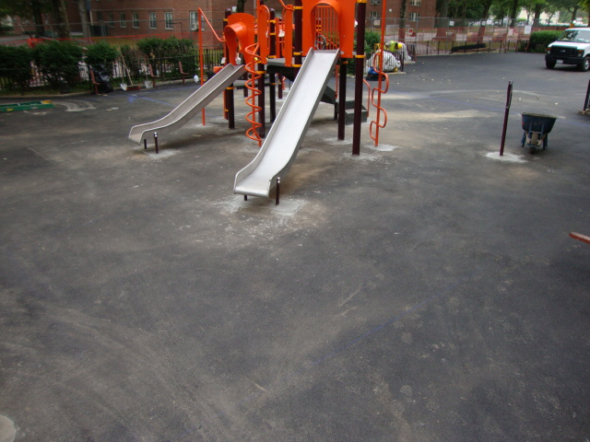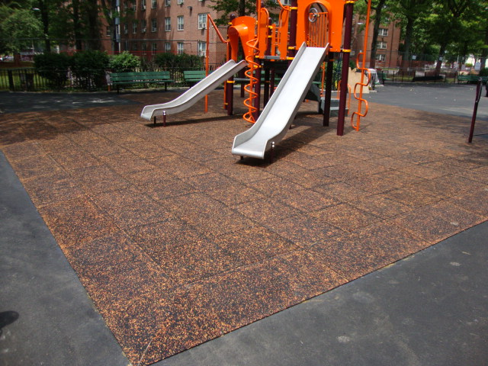

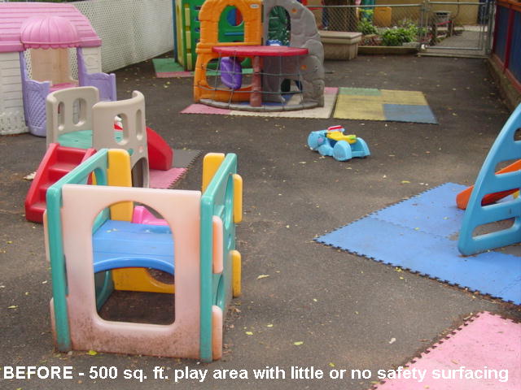 n 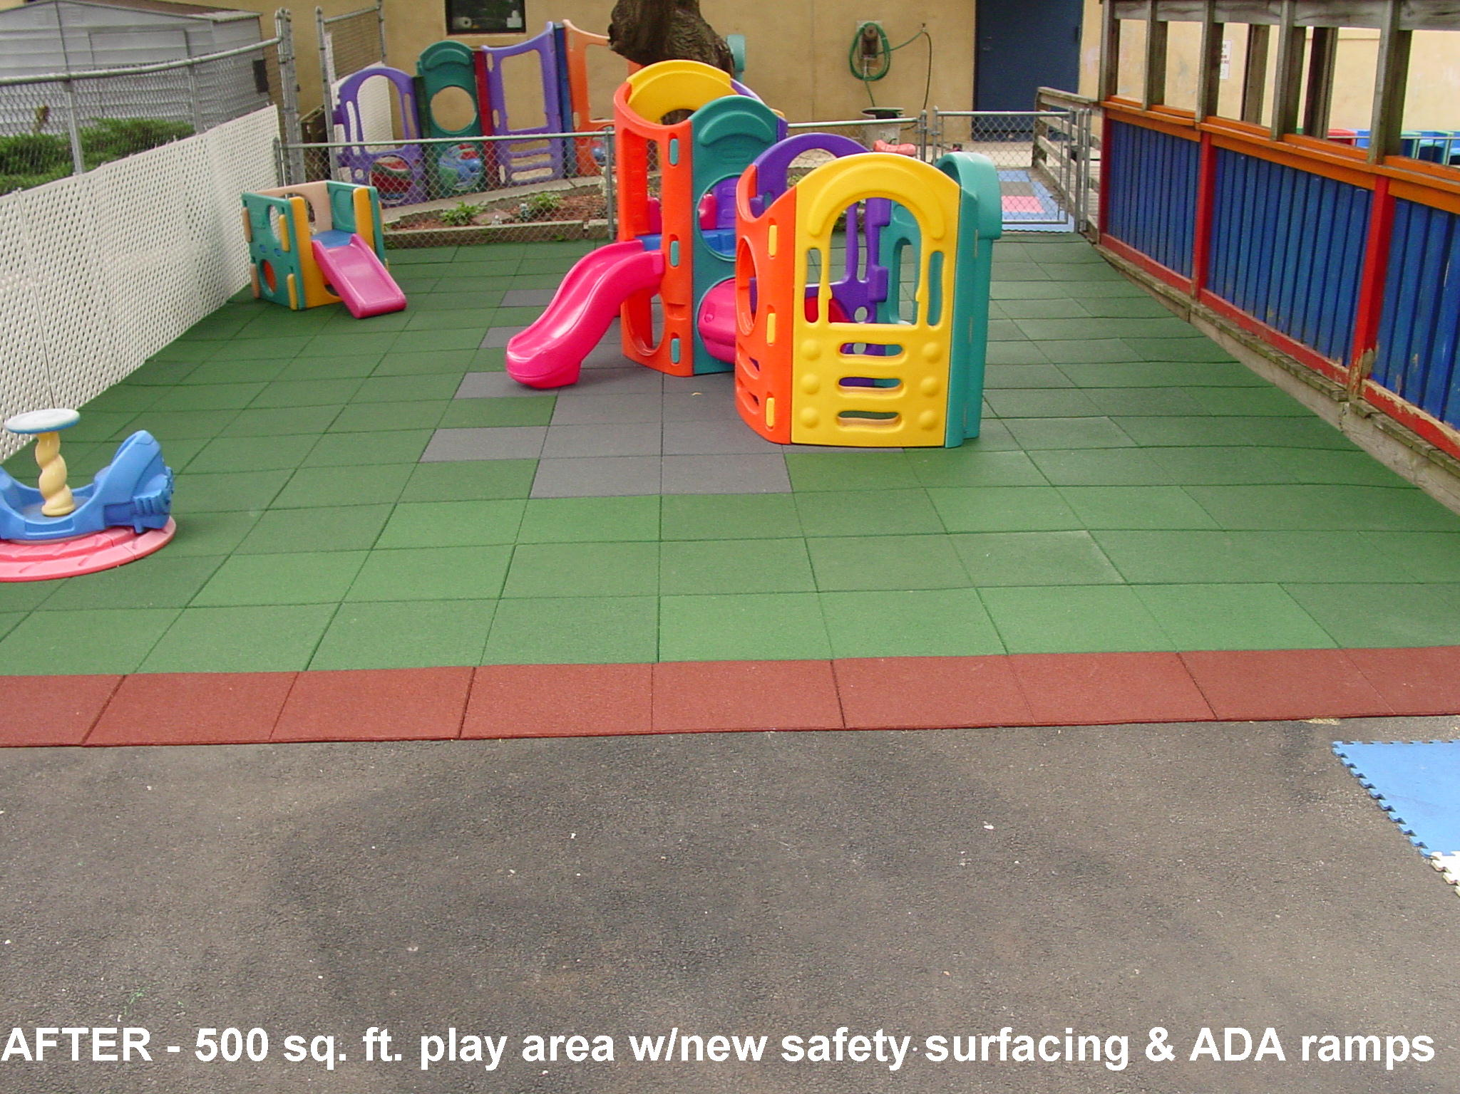

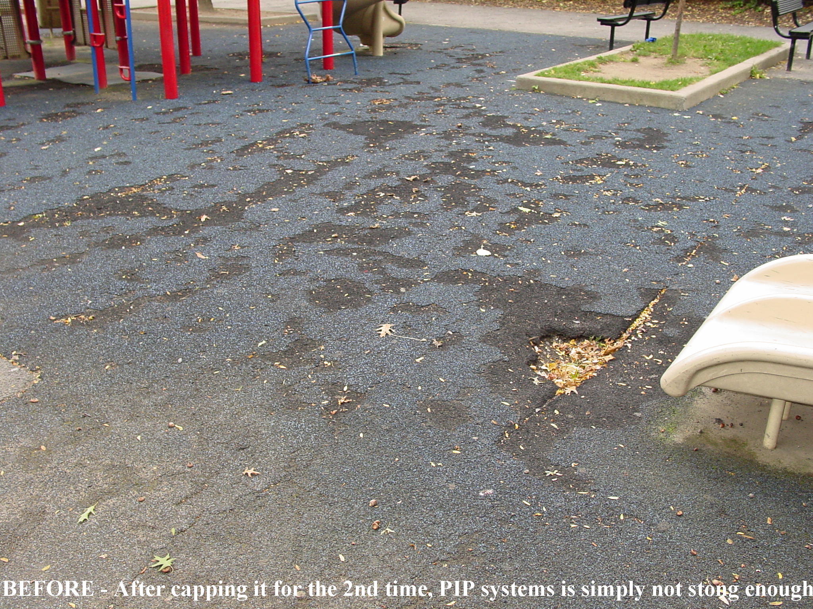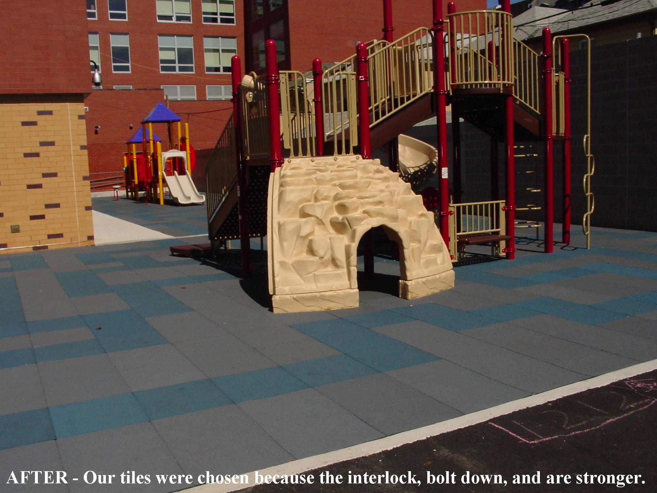
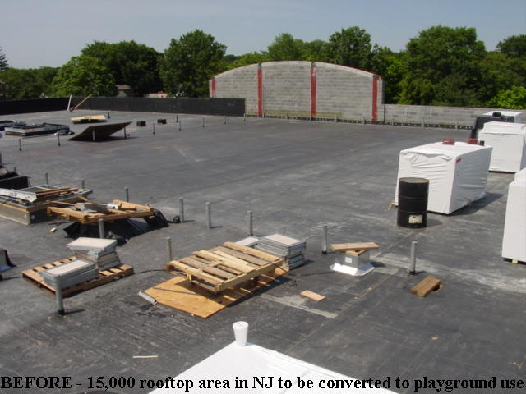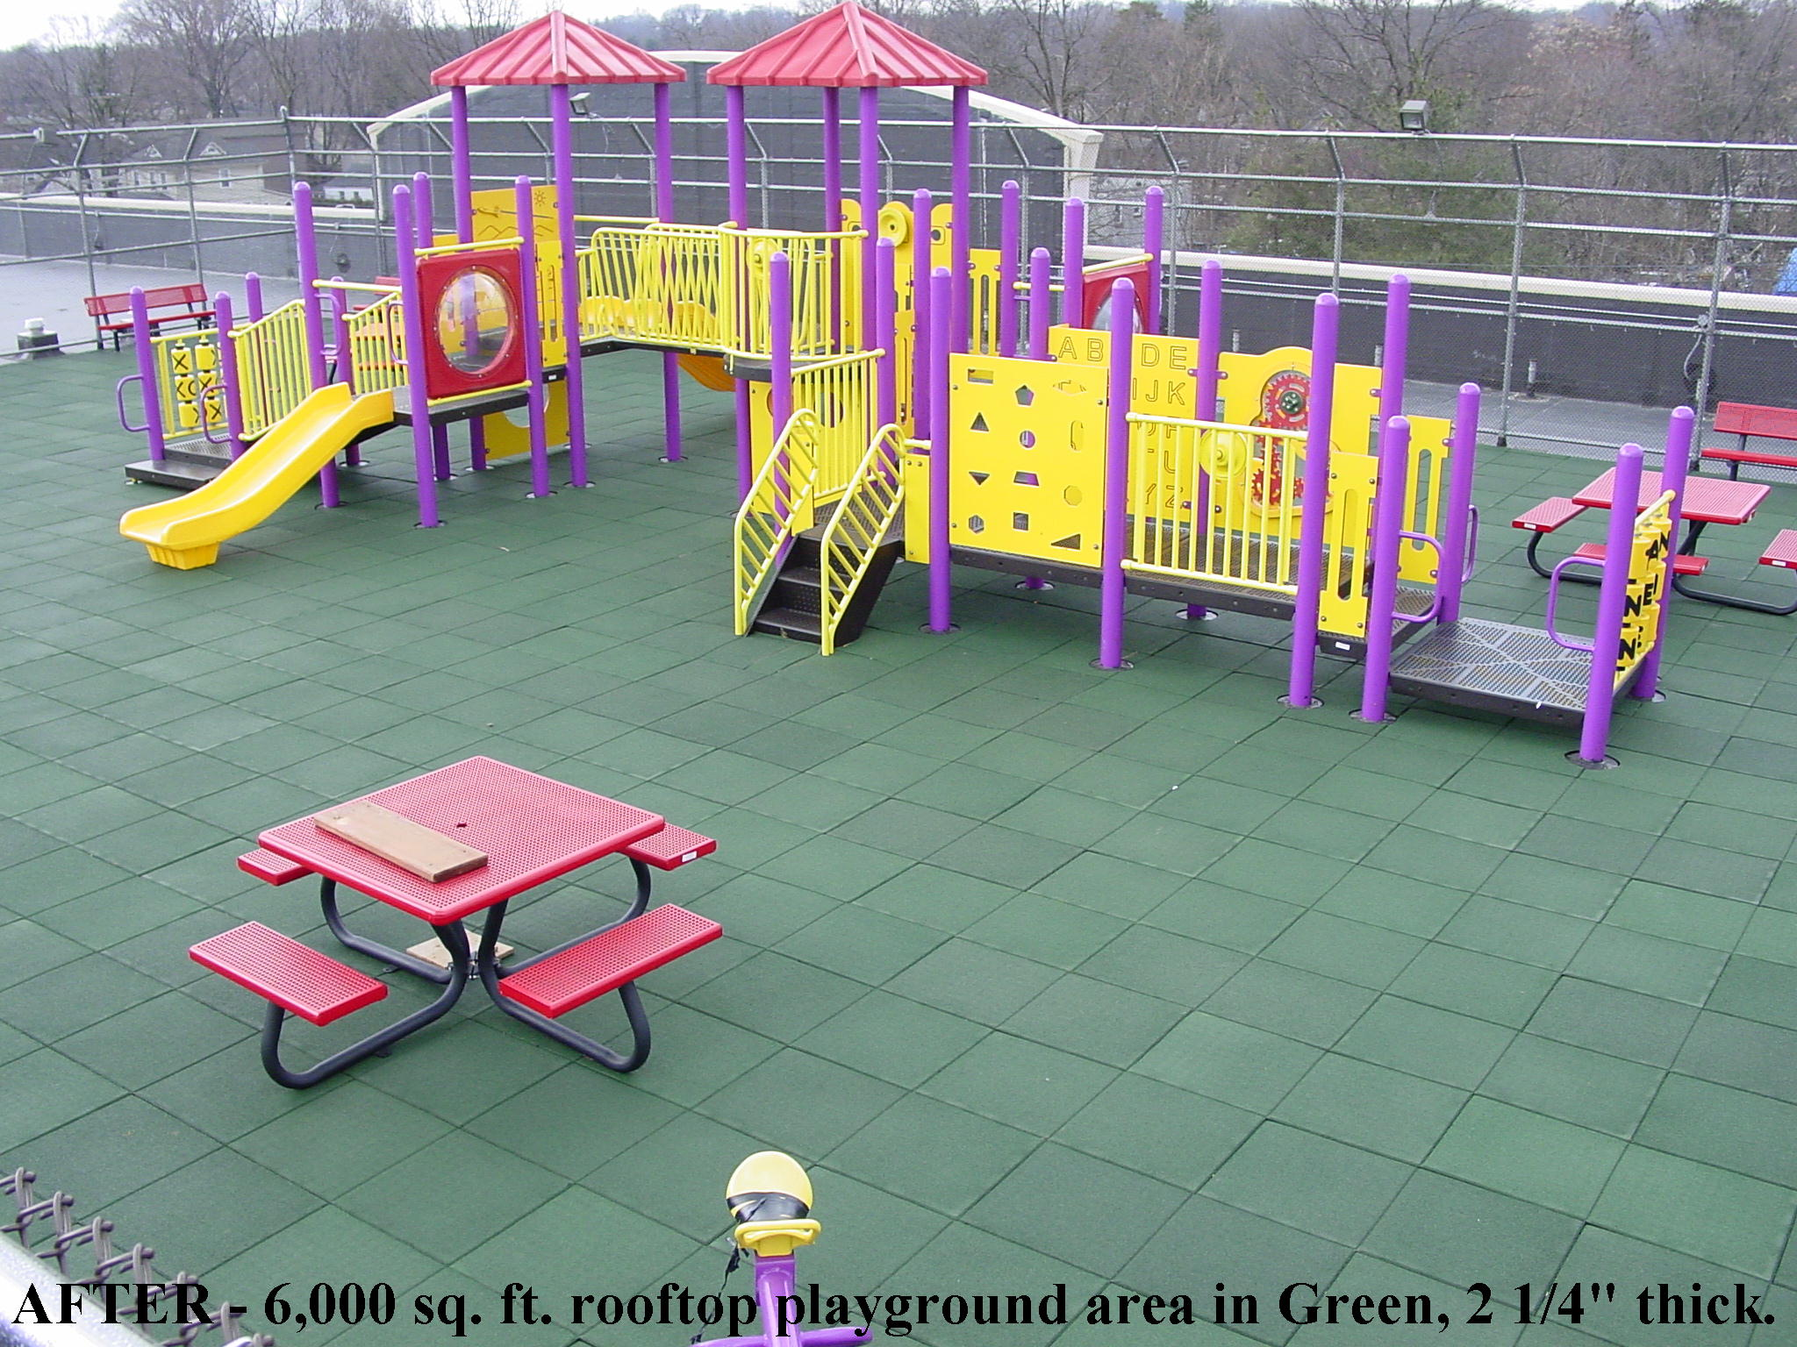

PART 6: REPAIR AND MAINTENANCE:
6.1) Repair:

A.) Repairing damaged items is simple and easy. Keep in mind, our products are 22”X44” (inches) and not 22”X22” as it appears when looking at the installed product (after an installation has occured). Take a crow bar with a flat edge (flat crow bar) and try to pry out the unit (or section) without damaging the surrounding area, especially the interlocking tabs.

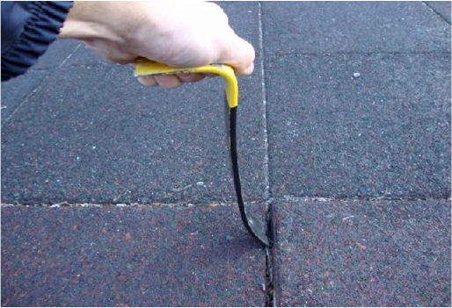

This will save the interlocks joints to be used again with the new (or same) unit being installed.

B.) Photograph below is of a roto-zip being applied to the “male” and “female” potion of the interlocking system. This is used to clean any and all glue from the unit to successfully re-install the item. Be sure to match the bit with the thickness (width) of the ‘female” and/or “male” interlock portions. Standard bit size recommended is half (1/2”) inch.

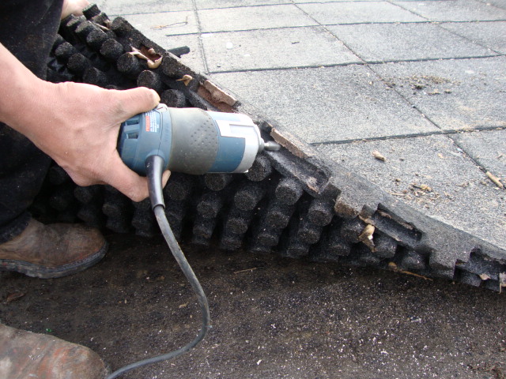

C.) If that cannot be accomplished, a utility knife will be needed to remove all the excess glue that was originally used to glue the interlocks together. The damaged unit can be lifted and discarded. Before installing a new or existing unit, remember to remove all loose debris from the area. Make sure the sub-surface below is in good condition. This will ensure a great fit with the existing units/products. Remember to glue the new units securely to the existing units to prevent vandalism. Do not use the area for at least 12 hours (overnight), 24-hours preferred.

6.2 Maintenance

A.) As with any other solid surface such as concrete, asphalt, cement, blacktop, etc., for outdoor usage, Unity’s products will need to be blown or vacuumed free of debris with a blower and/ or vacuum cleaner (shop vacuum). It is important to clean all of Unity’s products free of any debris as necessary. This will ensure that no debris gets in the seams of the tiles/mats/blocks/ pavers that may result in product-to-product separation and even vandalism. In turn, proper cleaning will help prevent such problems in the future.

B.) A sharp (firm) object may be used, and applied at the seam(s) for areas that has more debris than others to loosen up the stubbornness for easier blowing and/or vacuuming. Broom sweeping will only lock the debris in the seams and not remove it in its entirety.

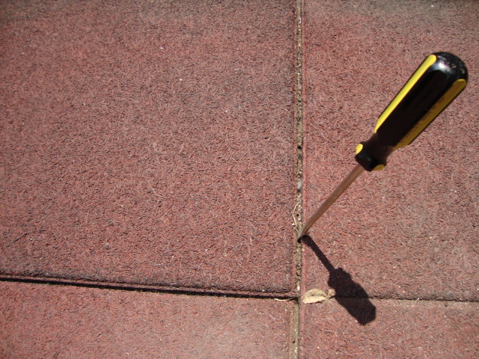

B.) When cleaning, use a mild detergent. Mix cleaner with warm to hot water as directed and apply to the floor with a wet mop and/or brush. Allow the cleaner to stand about five (5) to ten (10) minutes before removing with a clean damp mop. Rinse thoroughly until the rinse water is clear. Allow to surface to dry before using again. “Armorall” may be used to acquire a deep royal shine, however, it may be slippery at first.

C.) As for indoor use, when the floor is dry apply two thin coats of a cleaner (Mr. Clean) with a strip mop. Do not apply too heavily in one coat, as it may get slippery. Allow about thirty (30) minutes drying time between coats. It is not necessary to re-apply the cleaner to the entire area when maintaining the heavy traffic areas. Damp mopping the entire floor and using a cleaner in those abused areas is all that is necessary. “Armorall” may be used to acquire a deep royal shine, however, it may be slippery, especially indoors.

D.) Occasional major cleaning of the floor will require scrubbing with a bristled brush and/ or using a “power washer” with no more the 3000-PSI (as noted in the “During” picture below). After which one may apply the cleaner found above. Keep in mind, this product is water permeable and may result in excess water to find itself deep into the product. This is not an issue for exterior applications, but should be noted and addressed for interior applications.

PART 7: PAINTING

7.1) After many years of use, like other products on the market, our products can be painted for a fresh new look. This can provide less heat build-up and extend the life of the products for many years to come. Before = Before, During = After Pressure-washing. After = Painted.

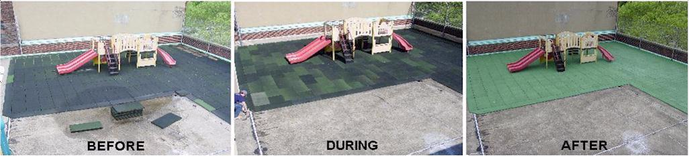

7.2) Our two-part paints (requiring on-site mixing) is a two-part process utilizing an “A” and “B” component. It can be simply sprayed on or rolled on (preferred) for a brand new look. In areas with multiple colors, it is recommended that a 22”X44” (inch) cut out using scrap cardboard be made to place over each product color. For example: if red and green are used in an area, make two (2) cut outs, one for red and one for green. Or if you prefer, tape off the area that is being painted to avoid any overspray or over rolling. Dump part B into part A and mix for one (1) minute. Apply the newly mixed paint allowing enough time to dry/cure (approximately three to four hours). Only mix enough material you can apply within your 2-4 window. Afterwards, you can enjoy the freshly painted area for longer.

PART 8: FILING SYSTEMS:

8.1) Additional product information is available from Unity Creations, Ltd. / Unity Surfacing Systems
upon written request.

8.2) Architectural Product Information Binder (Division 32, 9, 11) is available upon written request.

PART 9: TECHNICAL SERVICES:

9.1) Our staff of factory trained service personal can offer design assistance and technical support M-F
8AM-6PM. For assistance, contact: Unity Creations, Ltd. / Unity Surfacing Systems at (1-877) 41-
UNITY. E-mail: technicalinfo@surfacingsystems.com, or on the web at: www.surfacingsytems.com

PART 10: MEASUREMENTS

10.1) The quantity of rubber tiles/mats/blocks/pavers to be paid for under this item shall be the number of fake seams showing both sides of the tiles/mats/blocks/pavers in conjunction with two halves creating a whole, that have been furnished and installed to the lines and grades shown on the field measurements, and accepted in accordance with the plans and specifications and as directed by the architect of record.

PART 11: PRICE TO COVER

11.1) Rubber tiles/mats/blocks/pavers shall include the cost of furnishing the products (known as series), cutting of units, patch kits, adhesive, bolts, concrete base, labor, hardware, inspection services, samples, equipment, required submittals, mock-ups and testing, and other incidental accessories and expenses to complete the work in accordance with the plans and specifications and as directed by the architect of record. Refer to Civil items for trench drains, excavation, compacted aggregate base, and sub-base.

END OF SECTION 32 18 00 (02791)

Specifiers Notes

Introduction:
This specification product guide is written according to the Construction Specification Institute (CSI) and the Construction Specifications Canada (CSC) Format, MasterFormat, SectionFormat and PageFormat, as described in The Project Resource Manual – CSI Manual of Practice (April 2016 Edition). However, it is a 10-Part Format instead of a 3-Part Format.

The Section(s) must be carefully reviewed and edited by the Architect to meet the requirements of the project and local building code requirements. Coordinate the related Section(s) with other specifications section(s) and the Drawings accordingly. Delete all Specifiers Notes when editing.
1.1 Section Includes:
This covers Unity’s Tough-Land, Pave-Land, Soft-Land and XL Series of resilient, unitary, rubberized safety surfacing, flooring and paver products in the tile/mat/block/ paver form. Contact Unity for assistance in editing any of these Sections for a specific application.
1.2 Related Sections:
Edit the list of related Section(s) as required for the project. List other Section(s) with work directly related to this Section(s).

Include the Section(s) number(s) and title(s) of the Division(s) Section(s), if they are referenced in this section.

1.3 References:
List standards referenced in this Section(s), complete with designation(s) and title(s). This article does not require compliance with standards, as it is merely a listing of those used.
1.8 Warranty Information:
Refer to conditions of the overall Contract for project warranty provisions.
2.1 Manufacturer:
If a local representative is to be the key contact for questions and/or pricing on a local level, their company name, contact person information, address, phone number and e-mail address should be included herein.
2.2 Playground Protective Surfacing:
C.) Composition and Materials
3.) Specify thickness(es) of product based on the Critical Fall Height (CFH) and coordinate with working drawings.

D.) Thicknesses & Weights:
Specify weights and thickness based on Pigmented and or TPV top of each product/unit/ series being used.

E.) Wear Layer:
Specify 1 ¾”-4” thick products at 1” thickness.

G. Colors:
1.) Specify Pigmented and “Splash Design” top products on general applications where custom color combinations are not a primary design consideration. Made with Aromatic Binder. Splash Design can be used to create a speckled appearance.

2.) Specify Solid TPV top products when increased color retention and stability, a wider range of blending in design and/or matching an overall scope of the project is desired. Can be blended using up to three (3) colors at any percentages desired. Solid TPV top products can be used to create a marble or granite appearance. Made with Aliphatic Binder.

I.) Testing Data Results:
Specify Test Results in accordance with project details accordingly. Actual test reports, additional testing and additional product information are available upon written request.

4.2 Preparations:
Due to the Porosity of the Unity products, it is essential that a proper sub-base drainage system/run-off be used/constructed or else the products may not stay level and become damaged due to up-lift and/or shifting.

B.1) Crushed Stone Base – Ensure materials, compaction, thickness, slope and settling times are clearly specified.

B.2) Concrete Sub-base – Ensure that adhesive/glue will be used on the underside, outside edge, of each unit being installed.

B.3) Asphalt Sub-base – Ensure that adhesive/glue will be used on the underside, outside edge, of each unit being installed.

4.3 Installations:
Rooftop installations, Crushed Stone sub-base and temporary installations often call for adhesive to be applied to the interlocks only. In these cases, do not apply adhesive directly onto the roofing membrane or solid sub-base materials that are temporary without consulting an engineer, architect or end-user. Yield per tube will increase to 80 sq. ft. per tube.

D.) When using gallon pales for transitional ramps, yield is 50 sq. ft. per gallon.

